Order Set Style Guide

Flagler Hospital
400 Health Park Blvd. | St. Augustine, FL 32086
www.flaglerhospital.org
Contents
Document Overview 5
Organizational Process and Governance 5
Project Scope 5
Order Set Governance 5
Order Set Milestones and Tracking 6
Project Resources 6
Pilot Project 7
Knowledge Management 7
Order Set Structure and Standardization 7
Order Set Naming Convention 7
Sections/Subsection Levels 8
Section Names/Order 8
Subsection Names/Order 9
Catalog Considerations 10
Approved Abbreviations 10
Order Set Customization 11
Orderable/Reminder Inclusion and Exclusion Criteria 14
Reminders 14
Orderable Default States 14
Medication Orders 14
Non-medication Orders 15
Linkables 15
Fields Not To Be Used 16
Leveraging Zynx Default Content 16
Leveraging Zynx Default Content When a Custom Order Set Has Not Yet Been Built 16
Leveraging Zynx Default Content When a Custom Order Set Has Already Been Built 16
Blue Ribbons 17
Evidence Links 17
AuthorSpace Environment 18
Style Guide-Adherent Template in AuthorSpace 18
Folder Structure 19
Appendix A:

Document Overview

This document provides guidance for developing a consistent style for customizing order sets.

Organizational Process and Governance

Flagler Hospital Vision
It is our desire to implement an EMR which will link our community physicians with the hospital in such a way that all clinical staff will have immediate access to pertinent patient information not only at the point of care, but in whatever location they find themselves to be at that time. This will allow questions to be resolved as they arise, to respond to inquiries from the patient, the pharmacy, hospital staff or other clinicians who care for that patient.

While we recognize that this installation will be disruptive to current workflows, we intend to use this disruption to reengineer our workflows and increase the efficiencies of the healthcare we deliver. We also intend to eliminate the variations in how we deliver that healthcare which will lead us to increase the quality of the care we provide.

We also intend for all of our work to be guided by current clinical evidence which comes to us from the literature, current published society guidelines and Zynx evidence based data from their 1900 hospitals around the US.

Further, under emergency conditions, it is our intention to be able to provide access to vital patient information to non-Flagler Hospital physicians who need to care for one of our patients in setting remote to the hospital or our state.

Finally, we envision providing a patient portal to allow our patients to view their results and engage them in participating in their care in a meaningful way.

Project Scope
The scope of this project is to have 150 order sets at go-live. This includes 24 Allscripts Speed to Value (S2V) and 126 Zynx order sets. The S2V order sets will be integrated into Zynx after go-live.
PDF copies of all order sets will be stored on intranet site for downtime only.
Developers: explain the project scope, including how many order sets will be customized and how the

Order Set Governance
Process can be seen here in Appendix A.
Current Flagler Hospital order sets will be prioritized with the following grading scale by the PIT Crew physicians:
- Need at go-live
- Would like to have at go-live
- Can wait for after go-live
- Not being used
The graded order sets will then be compared with Zynx order sets. The 126 order sets to be used for go-live will be determined by Core physician group. Order sets will be customized by Zynx and Flagler Hospital (FH) Zynx team in AuthorSpace. FH Zynx team will then remove any modular pieces from order set and send to Pharmacy for review. The order set will then be handed off to PIT Crew SME physician. SME physician will have allotted time to discuss and analyze order set with their department (or with the department to whom the order set involves) and make adjustments. PIT Crew SME physician signs off and makes order set available for review to general medical staff in ViewSpace for comments. FH Zynx team will then compare the order set against this style guide and make appropriate changes. Order set will then be reviewed by the ancillary departments and then presented at next PIT Crew bi-weekly meeting. FH Zynx team will add back the modular pieces for finalization. FH Zynx team will integrate order set into Allscripts via OSIT tool for deployment.
Appeal process may be initiated after order set goes into production by submitting appeal in writing to Core physician group. The Core group will only act on landmark studies and or patient safety issues. All other appeal issues will be reviewed by PIT Crew.

Order Set Milestones and Tracking
During the customization process, the following milestones will be observed and tracked through Workflow Manager.

Project Resources
The following resources are allotted for this project:

Project Resources
Resource Title | Resource Description | Resource Name
Project Manager |  | Paul Phillips
Physician Champion |  | Dr. Michael Sanders
Zynx Integration Special |  | Allison Bell
Zynx PM |  | Michael Chen
FH Zynx Builders |  | Travis Thomas, Le-Ann Grierson, Jennifer Seymour
FH Zynx Coordinator |  | Jennifer Seymour
Pharmacist |  | Bill Bowen, David Snellen
Laboratory Reviewer |  | John Whetstone
Quality Reviewer |  | Melanie Miles-Kent, Marcie Carter
Risk Reviewer |  | Kevin Newman, Kathy Hennessey
Nursing Reviewer |  | Barbara Drummond-Huth
Radiology Reviewer |  | Dr. Arif Kudwai
Social Services Reviewer |  | Jill Yoerger
Cardio-Pulmonary Reviewer

Pilot Project
The order set to be used as a pilot: Dr. Prioleau’s Chest Pain Order Set

Knowledge Management
Order sets will be maintained according to the following criteria:
Evidence based updates: Critical (as notified by Zynx) and scheduled
Flagler Hospital will determine an order set review and maintenance schedule. Upon determining the schedule, the following will be considered:
- It is beneficial to stagger review dates on a rolling calendar schedule to avoid having to review all order sets at once.
- It is beneficial to group order set reviews by service or specialty.
- Order sets for which evidence may change frequently (eg, AMI) may require more frequent review.

Order Set Structure and Standardization

Order Set Naming Convention
Order set naming will be standardized based on the following conventions:

- PREFIX.Description Population (if applicable)
- Emergency Department orders-Only exception.
  - Prefix (ED).Description abbreviation (ABD, ORTHO, GEN, ENDO) Description
- EXAMPLES:
  - CARD. General Admission
  - ED. ABD General Pain

- Pre-fix: Service or Department Abbreviation are used (in Bold below)
  - ANES. Anesthesia
  - BARS. Bariatric Surgery
  - CARD. Cardiology
  - COMMON.
  - CORE.
  - CRIT. Critical Care
  - CTS. Cardio-Thoracic Surgery
  - ED. Emergency
  - GI. Gastrointestinal
  - HEM. Hematology
  - MED. Medicine (Internal)
  - NEPH. Nephrology
  - NEUR. Neurology
  - NSURG. Neurosurgery
  - OBGYN. Obstetrics and Gynecology
  - ONC. Oncology
  - OPTH. Ophthalmology
  - ORTH. Orthopedics
  - PEDS. Pediatrics
  - PULM. Pulmonary
  - RAD. Radiology
  - SURG. Surgery
  - URO. Urology
  - VASC. Vascular
- Description: Disease state or surgical intervention
- Population: Assumed adult unless listed as Peds or Neonatal
- External ID: The ID will be used for Order Sets required for Analytics/Outcomes Order Sets
- Order Set nomenclature also uses common clinical abbreviations like Pre-Op, Post-Op.

Sections/Subsection Levels
The number of section/subsection levels allowed is 2.
1 section level and 1 subsection level. This allows for clean and concise order sets that will work efficiently on paper, as well as integrating properly in a CPOE/EMR system.

Example:

Section Names/Order
The following section names and ordering are approved for use for all order sets other than those that will be used in the Emergency Department:
“ADCVANDIMLE”
Admission
General
Activity
Nursing Orders
Diet
IV Fluids
Respiratory
Medications
Laboratory
Diagnostic Tests
Radiology
Consults
Blood Bank
Patient/Caregiver Education
Reminders

The following section names and ordering are approved for use for all order sets that will be used in the Emergency Department:
“ADCVANDIMLE”
General
Diet *
Laboratory
Diagnostic Tests
Radiology
IV Fluids
Medications
Nursing Orders
Respiratory
Blood Bank
Patient/Caregiver Education
Consults
Reminders
*In almost all cases this should be defaulted to NPO

Subsection Names/Order
The following subsection names and ordering are approved for use:
Subsection Names and Ordering
Section | Subsection
Laboratory | STAT, Routine, Micro, Other
Diagnostic Tests | EKG, Other
Radiology | CT, MRI, US, X-ray, Nuc Med, Interventional Rad,
Nursing Orders | Assessments, Interventions, Other
Medications | Keep Zynx medication sublevels by class of medication
Respiratory | Assessments, Interventions, Other
Consults | Service, Notifications, Ancillary, Other

For order sets that include PRN medication for critical care situations or decompensating patients’ conditions, the medication will be listed under “Antidote and Rescue Medications” sublevel. Example: Physician’s order: Dopamine PRN for SBP < 90, titrated to keep SBP > 100.
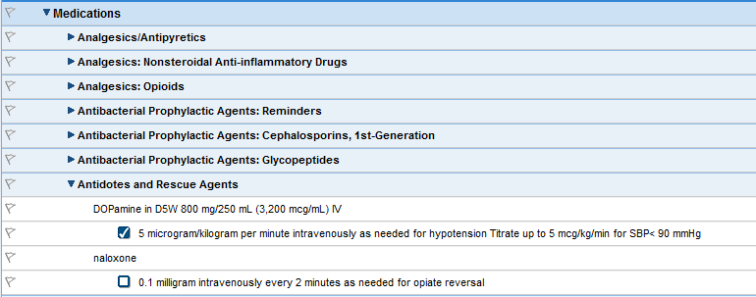

Catalog Considerations
Custom catalog terms are not to be created directly in AuthorSpace, they will be created in the Allscripts’ database directly.
When browsing for terms, use a custom catalog term preferentially. If an appropriate custom catalog term cannot be found, use an equivalent Zynx catalog term. If neither a custom catalog term nor a Zynx catalog term can be found, use free text in the “Override” field in the order item workspace. Custom terms may later be added to the custom catalog, imported into AuthorSpace, and swapped in for Zynx or override terms.

Abbreviations
The following abbreviations are may not be used:
JCHAO Official “Do Not Use” List
Do Not Use | Potential Problem | Use Instead
U, u (unit) | Mistaken for “0” (zero), the number “4” (four) or “cc” | Write "unit"
IU (International Unit) | Mistaken for IV (intravenous) or the number 10 (ten) | Write "International Unit"
Q.D., QD, q.d., qd (daily)  Q.O.D., QOD, q.o.d, qod  (every other day) | Mistaken for each other  Period after the Q mistaken for "I" and the "O" mistaken for "I" | Write "daily"  Write "every other day"
Trailing zero (X.0 mg)*  Lack of leading zero (.X mg) | Decimal point is missed | Write X mg  Write 0.X mg
MS  MSO4 and MgSO4 | Can mean morphine sulfate or magnesium sulfate  Confused for one another | Write "morphine sulfate"  Write "magnesium sulfate”
Problem Term Reason Suggested T
The following symbols may not be used:
erm
Do Not Use | Potential Problem | Use Instead
> (greater than)  < (less than) | Misinterpreted as the number “7” (seven) or the letter “L”  Confused for one another | Write “greater than”  Write “less than”
Abbreviations for drug names | Misinterpreted due to similar abbreviations for  multiple drugs | Write drug names in full
Apothecary units | Unfamiliar to many practitioners  Confused with metric units | Use metric units
@ | Mistaken for the number  “2” (two) | Write “at”
cc | Mistaken for U (units) when poorly written | Write “mL”  or "ml" or “milliliters”  (“mL” is preferred)
μg | Mistaken for mg (milligrams) resulting in one thousand-fold overdose | Write "mcg" or “micrograms

ISMP List of Error-Prone Abbreviations, Symbols and Dose Designations
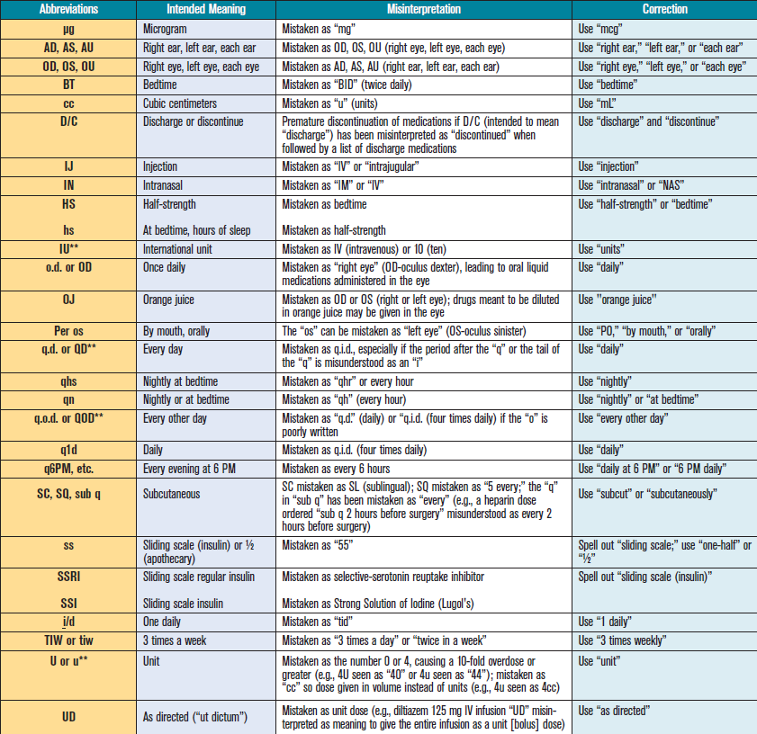
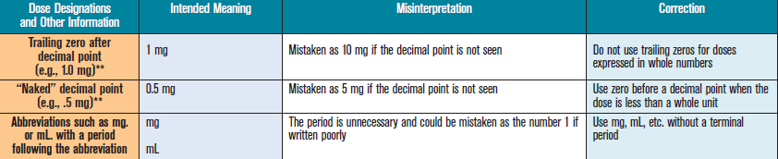

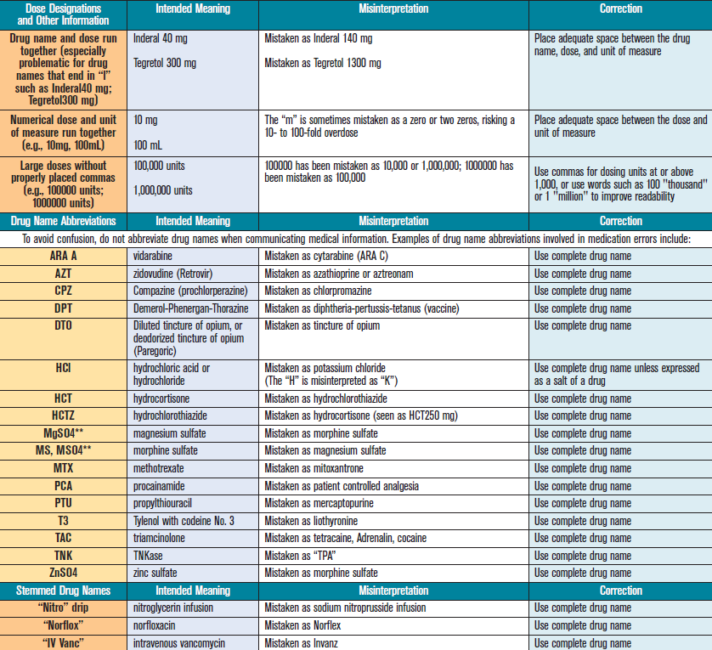

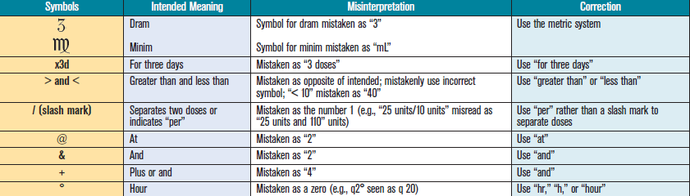

Order Set Customization

Orderable/Reminder Inclusion and Exclusion Criteria
Developers: to limit order set length and enhance usability, consider limiting the allowable order items and reminders to those most specific to a given condition, procedure, clinical venue, etc.

Reminders
Developers: reminders are clinical decision support statements used to prompt and guide clinicians during the ordering process. Example of a reminder:
Reminders should not be used to communicate information to the interdisciplinary care or nursing teams, as they may not be transmitted downstream in most CPOE/EMR systems or when “Print Only Selected Items” is used in Zynx interactive PDF forms; instead, such information should be included as details within an order sentence.

Orderable Default States
Developers: develop criteria for use of the 3 orderable default states (definitions below). For example, you may choose to stipulate that the most common orderables will be default-selected; vital signs orderables might be required-selected; and so forth. Note that all 3 states may be used within a single order set. The default states are:
- Optional: the orderable’s check box is not preselected in the order set.
- Default: the orderable’s check box is preselected in the order set, but may be changed by the end-user.
- Required: the orderable’s check box is preselected in the order set, and may not be changed by the end-user.

Medication Orders
Flagler Hospital will use a standard medication naming convention (ie, generic name, brand name, or generic plus brand name).
Additionally, Flagler Hospital will use the following guidelines when naming medications:
- Include only medications that are part of the hospital’s formulary.
- Use tall man lettering as per ISMP guidelines: http://www.ismp.org/tools/tallmanletters.pdf.
- Follow ISMP recommendations for error-prone abbreviations, symbols, and dose designations: http://www.ismp.org/Tools/errorproneabbreviations.pdf.
- Include medication name + dose + dose unit + route of administration + frequency + duration + duration unit, where applicable.
- Include a PRN reason, where applicable.
- Include leading zeros (eg, 0.1 mg).
- Do not use apothecary units (eg, grains, drams).
- Do not use drug name abbreviations (eg, MSO4).
- Do not use fractional units.
- Do not use trailing zeros (eg, 100.00 mg).

Non-medication Orders
- For admissions, the order must include:
  - Admitting service
  - Admitting physician
  - Location/unit: Obs, M/S, ICU, Peds, NICU, Psych, etc
  - Specific whether the patient is to be on telemetry or not
- For communication orders, include parameters that are clear and descriptive; for example: “Notify provider for heart rate less than 60 or greater than 110.”
- For patient care/nursing orders, include only those items that are not covered by internal nursing policy/procedure; for example: include “Weight on admission” only if not already included in internal nursing policy/procedure.
- For diagnostic and radiological procedure orders, include:
  - priority
  - frequency
  - reason/indication
- For lab orders, include:
  - priority
  - frequency
  - duration
- For consult orders, include the reason for the consult if a reason (ie, a reason common for the particular consult) can be predetermined. For example, “Consult to nutrition for new onset diabetes,” “Consult to nutrition for TPN initiation,” eg.
- For physician-to-physician consults communication between the physicians must be verified.

Linkables
Linkables are short order sets that can be inserted into other order sets. Linkables provide consistency between order sets, and also convenience, as any change to the linkable automatically appears in every instance of the linkable. Linkable order sets created in Zynx will be exported individually and placed into Allscripts. They will be inserted into any applicable Allscripts order sets in the REFERENCE SETS section.
Flagler Hospital will avoid creating a linkable within a linkable. The following linkables may be used:
Linkables
DVT Prophylaxis
Potassium Electrolyte Replacement Protocol
Heparin Drip Protocol
Sliding Scale Insulin/Glycemic Management

Fields Not To Be Used
During the initial build phase of the Zynx order sets, the Flagler Hospital order set build team may identify certain fields that will not be used in implementation.

Leveraging Zynx Default Content
Zynx default content (eg, sections, subsections, reminders, orderables) from an applicable Zynx default order set may be included in a custom order set. The two following options will be used to include Zynx evidenced-based content:

Leveraging Zynx Default Content When a Custom Order Set Has Not Yet Been Built
When a custom order set has not yet been built, Zynx default content may be included in the custom order set as follows:
- Copy and paste the applicable Zynx default order set into the (otherwise blank) custom order set area.
- Consider which Zynx default items you would like to retain in the custom order set. Give strongest consideration to including those items that have a blue ribbon (defined below) or evidence link (defined below).
- For Zynx default items you would like to retain, you may, if desired, open the item’s workspace and customize it.
- Delete any Zynx default items you do not wish to retain.
- Build your custom content, positioning it however you like in relation to the Zynx default items.

Leveraging Zynx Default Content When a Custom Order Set Has Already Been Built
When a custom order set has already been built, Zynx default content may be included in the custom order set as follows:
- Insert a dividing row called “Zynx Default Order Set” at the bottom of the custom order set content.
- Copy and paste the appropriate Zynx default order set below the dividing row (ie, at the bottom of your custom order set space).
- Consider which Zynx default items you would like to incorporate into the custom order set. Give strongest consideration to including those items that have a blue ribbon (defined below) or evidence link (defined below).
- If an equivalent item already exists in the custom order set, you may do one of the following:
  - Drag and drop the Zynx default item next to the equivalent item in the custom order set. Open and customize the Zynx default item workspace if desired. Delete the original equivalent item.
  - Or, hover over the Zynx default item’s blue ribbon (or open the workspace) to see the associated regulatory agencies (eg, The Joint Commission), and then manually associate those same regulatory agencies with the equivalent item in the custom order set. Do the same for the Zynx default item’s evidence link.
- If an equivalent item does not already exist in your custom order set, drag and drop the item to the desired location within the custom order set.
- Delete any Zynx default items you do not wish to retain; ie, all of the items that still remain below the dividing row after the leveraging of Zynx default content has been completed.

Blue Ribbons
A blue ribbon indicates that the orderable or reminder is associated with 1 or more performance measures (tracked nationally by 1 or more quality or safety regulatory agencies).

Developers: consider including in the custom order set all items from the Zynx default order set that have a blue ribbon. Alternatively, blue ribbon items may be addressed via another organizational process or mechanism; eg, smoking cessation counseling or education performed as part of a system-generated rule or alert, or via an automated documentation process.

Evidence Links
Individual sections, subsections, reminders, and orderables may have a link to a Zynx evidence page.

Developers: consider including in the custom order set all items from the Zynx default order set that have an evidence link. Custom evidence links (ie, links to other Web pages) may also be considered.

Key Clinical Processes

Key clinical processes are icons that denote evidence based interventions that are associated with reducing cost, mortality, admissions/readmissions and length of stay.

Developers: consider including in the custom order set all items from the Zynx default order set that have a key. Alternatively, key clinical process items may be addressed via another organizational process or mechanism, performed as part of a system-generated rule or alert, or via an automated documentation process.

AuthorSpace Environment

Style Guide-Adherent Template in AuthorSpace
The Flagler Hospital order set style templates can be found in the 2. In Production folder and are as follows:
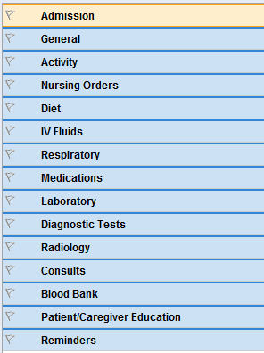

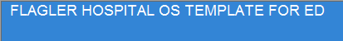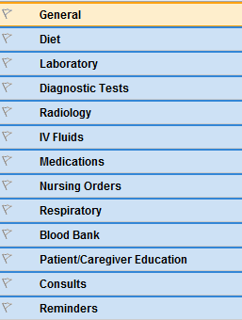

Folder Structure
The AuthorSpace environment will be organized in the following manner:

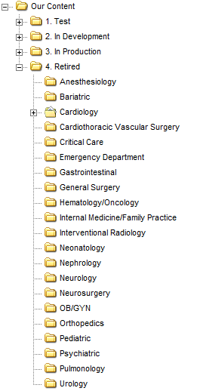

APPENDIX A:

Order Set Governance

